 | Vinod Kumar <pvinod2109@gmail.com>
Booking Confirmation
2 messages
donotreply@ksrtc.in <donotreply@ksrtc.in> | Thu, Sep 21, 2017 at 06:00 AM
To: Pvinod2109@gmail.com
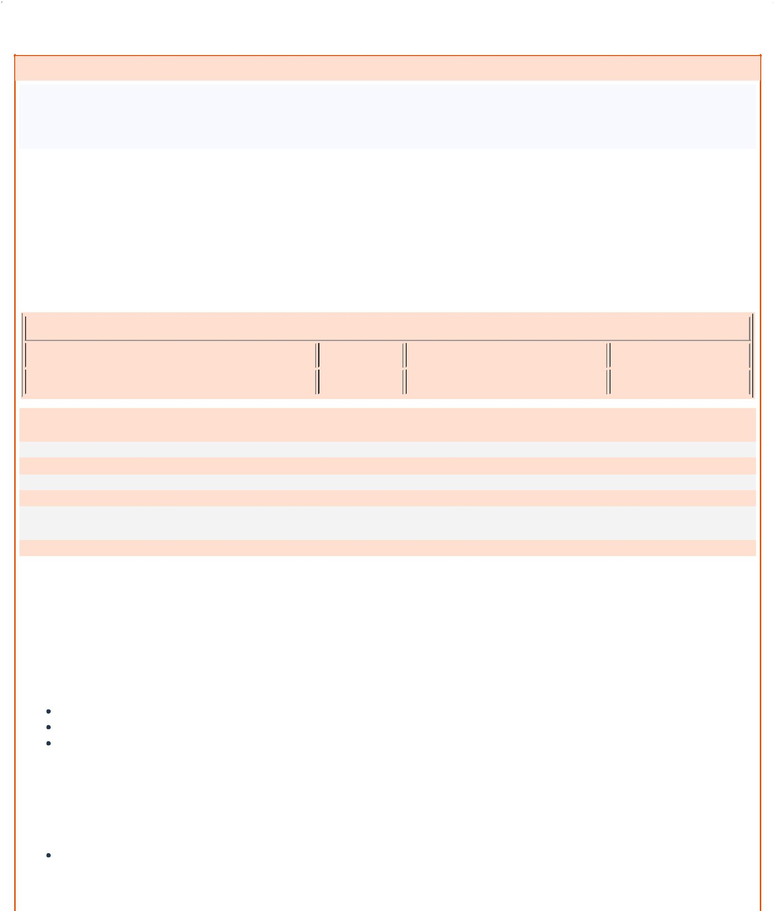

E-Ticket/Reservation Voucher

KARNATAKA STATE ROAD TRANSPORT CORPORATION

Central Office, Transport House, K.H ROAD, Bengaluru - 560027, Karnataka, India.
Telephone No. : 080-49596666

Homepage : http://www.ksrtc.in

PNR Number : |  |  | T66847391 | Date of Journey : |  | 21-Sep-2017
Trip Code : |  |  | 1800BNGDVG | Class of Service : |  | A/C SLEEPER
Seat No(s) : |  |  | 18 | Service Start Place : |  | KEMPEGOWDA BS MAJESTIC
Boarding Point : |  |  | KEMPEGOWDA BS MAJESTIC | Departure Time : |  | 06:30
Platform No : |  |  |  | Txn Password: |  | 2849
Passenger End Place : |  |  | CHITRADURGA
Alighting Point : |  |  | CHITRADURGA
No. of Seats : |  |  | 1 ( Adults: 1 Children: 0 )

Passenger Information

 | Name |  | Age |  | Adult/Child |  | Gender
 | P VINOD KUMAR | 24 |  |  | ADULT |  | Male

Total Fare Deatails :

Original Basic Fare : 720.0
Concession Fee : 0.0
Basic Fare : 720.0
Reservation Fee : 10.0
GST : 35.0
Levies : 73.0
Total Fare : 838.0 (incl. of Reservation Fee: 10.0, Payment Gateway Charges: )
Enroute Refrehment Stops :

ID Proof Note :

During bus journey, one of the passenger on an e-ticket appears should carry the original identity card such as: Driving License, Election Card, Ration Card, Photo ID card issued by Central/State Govt./Private Organisations, AdharCard, Pan Card, Passport, Credit Card with Photo identification, Student ID issued by any Institute, Pass Book with Photo issued by any Nationalised Bank ,CAT CARD issued by KSRTC.

Important

The seat(s) booked under this e-ticket/m-ticket is/are not transferable.

This e-ticket is valid only for the seat number and bus service specified herein.
This e-ticket/m-ticket /m-ticket has to be carried by the passenger during the journey along with any one of the following ID proof; Driving License (Original/Photo copy), Voter ID Card (Original/Photo copy), PAN Card (Original/Photo copy), Passport (Original / Photocopy), Ration Card (with passenger photo, Original/Photo copy), Senior citizen ID card (issued by KSRTC / Govt., Original/Photo copy), ID card (with Photo) issued by Govt Depts (Original/Photo copy), Private company ID card (original), Educational Institution ID card (original). Physical copy of Identity proof needs to be produced. Scan / images of identity proof are not allowed.

E-ticket/m-ticket will become INVALID, if ID proof or e-ticket / m-ticket is not produced and passengers will be treated as 'Travelling without ticket'. He will need to procure fresh ticket from Conductor by paying the applicable fare for travelling.
Passenger shall keep the e-ticket/m-ticket safely till the end of the journey.
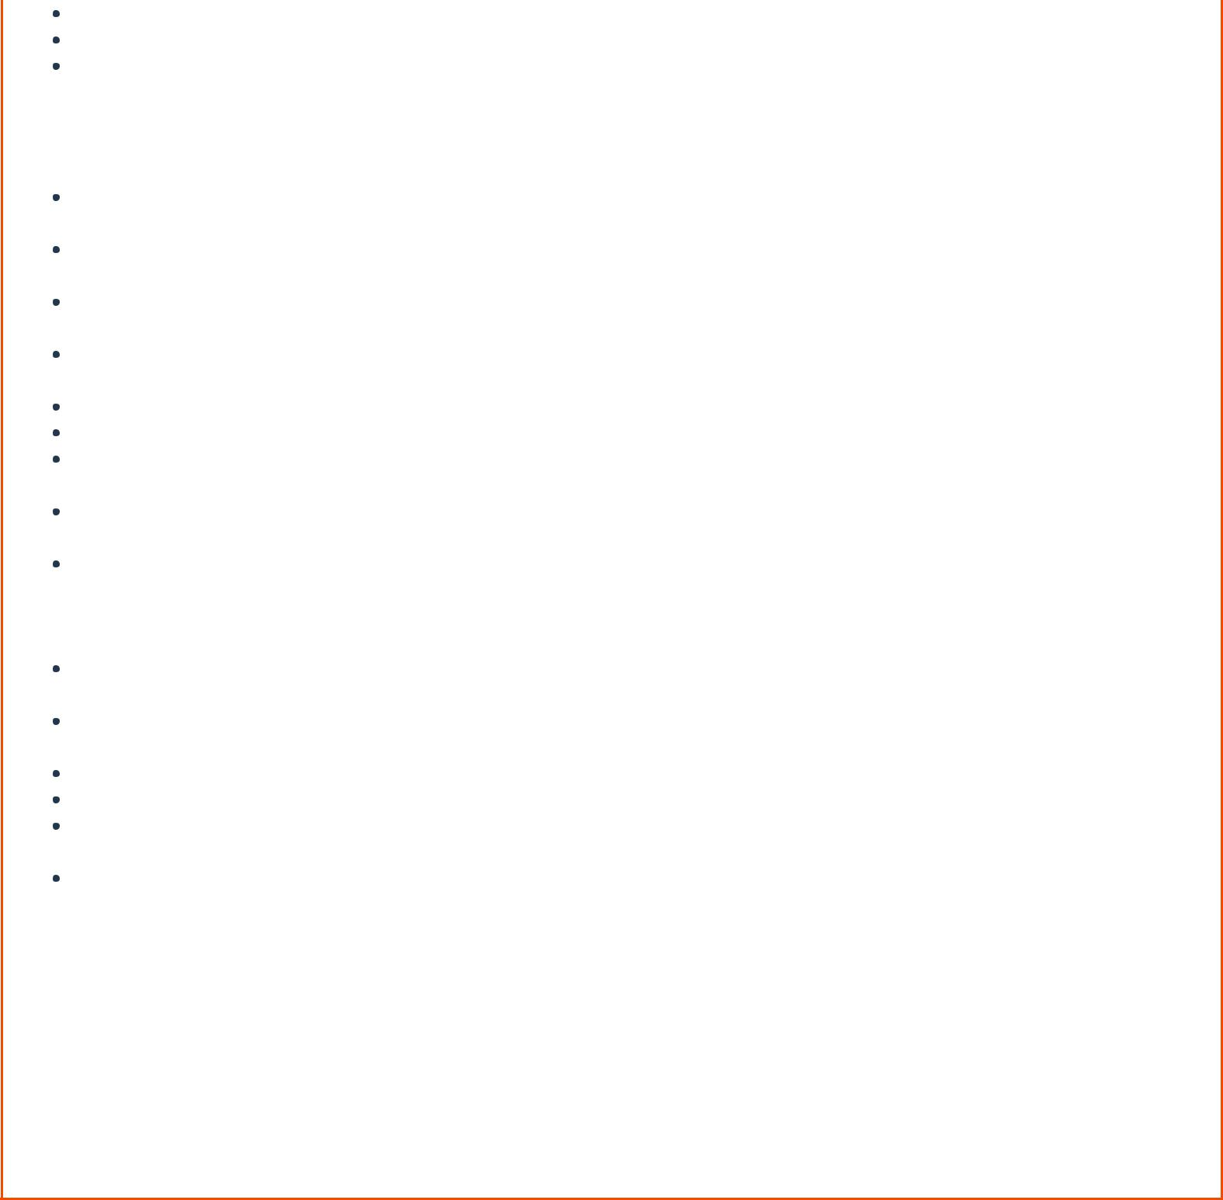
Passenger shall show the e-ticket/m-ticket and ID proof at the time of checking.
Senior Citizen concession is applicable for residents of Karnataka State only. Residents of other states are not entitled for Senior Citizen concession. Passengers travelling with Senior Citizen concession need to produce any one of the following Original ID proof at the time of journey - Senior citizen identity card issued by KSRTC, Identity card issued by the Physically Challenged and Senior Citizens Welfare Directorate, Driving Licence, Voter ID and Passport, issued by the concerned authority of State of Karnataka.

Free Travel is permitted in City Buses (except A/C buses) within the City limits before 2 Hours of the departure time on production of e-ticket print-outs only. Free travel by showing m-ticket is not allowed.

All departure / arrival timings are in 24 hour format i.e 8:00 AM will be displayed as 08:00 hrs and 8:00 PM as 20:00 hrs.

If booked e-ticket/m-ticket does not meet passenger requirements, user needs to cancel the ticket and rebook with correct details.

Refunds for cancellation of online e-ticket/m-ticket will be made to customer's bank account only. Cash refunds are not allowed.

Cancellation of online e-tickets/m-ticket by the user is confirmed through email And SMS No refund is allowed for No-show e-ticket/m-ticket or tickets not used for travel.

Passengers are requested to arrive at the Boarding / Pickup point at least 10 minutes before the scheduled time of departure of service.

Delivery of SMS (m-ticket, trip sheet alerts, service alerts etc.) depends on mobile service provider of the user and KSRTC is not responsible for its delivery.

If passenger faces any problem in cancellation of tickets, it needs to be reported by email to awatar@ksrtc.org, immediately. Such mails will be considered based on the date and time of the mail and upto two hours before the departure of the service. Such email shall be sent from registered user or guest user email id only. Mails received after this time or from different email id will not be considered for refund.

Any personal luggage or belongings should be taken care of by the passengers themselves. KSRTC is not responsible for passenger luggage / personal belongings inside the bus and during the journey. KSRTC reserves the right to off-load passengers who are travelling on incorrect tickets, disturbing co-passengers and also drunken passengers without refund of fare.
Smoking and consumption of alcohol is strictly prohibited inside the bus.
Corporation reserves the rights to change/cancel the class of service.

For detailed terms and conditions, refer 'Reservation Terms' on KSRTC website (www.ksrtc.in Reservation Terms).

All users are requested 'Not to share their online banking / Credit card / Debit card details to any person from any organization'. Enquiry 7760990562, Call center 080-49596666.

Booked By | ONLINE | Booked On : | 21-Sep-2017
Name : | ONLINE | Booked On : | 06:00
^{*** WISH YOU HAPPY}SRVC START TIME @ORIGIN 22:30 HRS ***
JOURNEY.,

Thank you.

ksrtc.IN

This message was sent from a notification-only email address that does not accept incoming email. Please do not reply to this message.

For e-Ticketing/Refund Related Queries : onlinerefund@ksrtc.org

For Other Queries: awatar@ksrtc.org

